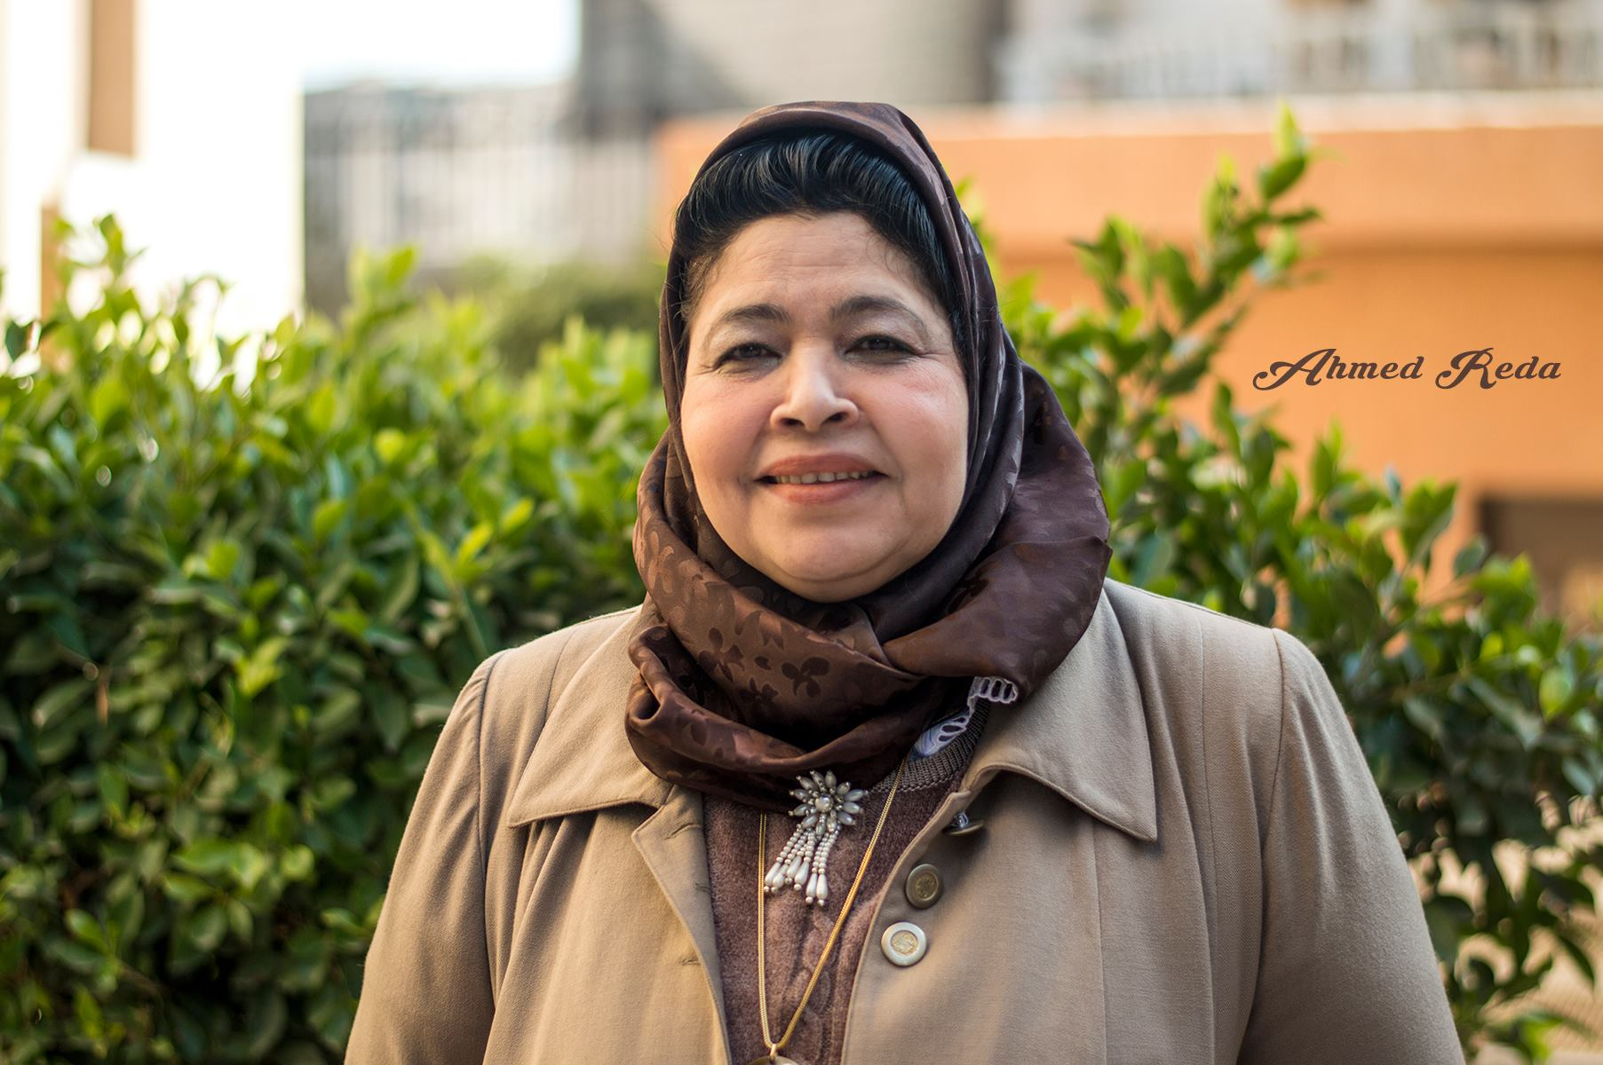C.V of Prof Dr. Elham M. Salama, BSc., MSc. PhD.,FRES
Professor of Entomology
Personal Data
Salama | Sure name
Elham | First Name
Female | Gender
Married | Marital Status
19 Novmber 1959  Egyptian | Date of Birth
May; 1982 | Nationality  Date of Graduation
Mohandsin Tower, Building 7, Floor 11 , Flat No. 1Chonishe Maady St. Cairo, Egypt | Address of Home
Home: +20 0133274636; Mobile: +2 01223750805  dre_salama@yahoo.com  drelham_salama@hotmail.com | Tel:
Prof. of Entomology, Faculty of Science, Department of Entomology, Benha University, Egypt. | E- mail  Current Position Address of work
Fax: +20133222578 Tel: +20133225494, P.O. Box 13518
E-mail: elham.salama@fsc.bu.edu.eg

Degrees Awarded
- 1- B.Sc., Faculty of Science, Ain Shams University. With Excellent Grade. Egypt (1982)
- 2- M. Sc. in Entomology, Faculty of Science, Benha Branch, Zagazig University. Egypt, (1989)
- 3- Ph. D Degree in Entomology, Faculty of Science, Benha Branch, Zagazig University. Egypt, (1994)
- 4- Awarded Post-Doctor Fellowship, In the Department of Life Sciences, At Nottingham Trent Univ., England, U.K, (1999)
- 5- Assistant Prof. in Entomology, Faculty of Science, Benha University. Egypt, (2003)
- 6- Prof. of Entomology, Faculty of Science, Benha University. Egypt, (2016)
Employment History & Affiliation
- 1-Demonstrator in Entomology, Faculty of Science, Benha Branch, Zagazig University. Egypt, (1983-1989).
- Lecturer Assistant in Entomology, Faculty of Science, Benha Branch, Zagazig University. Egypt, (1989-1994).
- Ph.D. Postgraduate Student, Biological Sciences Dept., Nottingham Trent Univ., Nottingham, England (4,11-1999).
- Lecturer of Entomology , Faculty of Science, Benha Branch, Zagazig University. Egypt, (1999-2003).
- Dean of Faculty of Education for Girls , Saudi Arabia (2001-2002).
- Assistant Prof. of Entomology, Faculty of Education , El-Karj University Saudi Arabia (2002-2011).
- Head of Biology Department , Faculty of Education , El-Karj University Saudi Arabia (2005-2011).
- Associate Prof. of Entomology , Faculty of Science, Benha University. Egypt, (2003- until now).
- Prof. of Entomology, Faculty of Science, Benha University. Egypt, (2016)
Membership & Fellowship
- Member of the Egyptian Scientific Syndicate.
- Member of the Entomological Society of Egypt.
- Member of the Egyptian and German Zoological Society.
- Member of European Society of Photobiology.
- Member of the American Entomological Society USA.
- Member of the Indian Entomological Society India.
- Fellow of the Royal Entomological Society UK.

List of publication for Professor Dr. Elham M. Salama
1- SCREENING THE SUSCEPTIBILITY OF SOME PHOTOSENSITIZERS AS A PHOTO-INSECTICIDE ON Spodoptera furgipedra SF9 CELL LINE IN VITRO
By
Elham M. Salama
Entomology Department, faculty of Science, Zagazig University, Benha branch, Egypt (2000)
Proc. I.C.B.S., 1 (2) 2000: 77-84.
2-THE COMBINED EFFECT OF THE PHOTO-INSECTICIDE HEMATOPORPHYRIN AND THE INSECT GROWTH REGULATOR DIMILIN ON Culex pipiens LARVAE.
By
Elham M. Salama
Entomology Department, Faculty of Science, Zagazig University, Benha branch, Egypt (2000)
Proc. I.C.B.S., 1 (2) 2000: 123-132.
3-JOINT ACTION OF INSECTICIDE MIXTURES ON RESISTANT STRAIN OF Culex pipiens LARVAE
BY
ELHAM M. SALAMA, MOHAMED S. HAMED*, SOAD M. EL-HOSARY
Entomology Department, Faculty of science, Zagazig University, Benha branch, Egypt.
*Entmology Department, Faculty of Science, Ain Shams University, Egypt
Sic. J. Fac. Sci., Menufiya Univ. Vol.XVI (2002) ( 15-26).
4- RESISTANCE CHARACTERIZATIONS OF BAYGON INSECTICIDE IN Culex pipiens LARVAE
By
ELHAM M. SALAMA, MOHAMED S. HAMED*, SOAD M. EL- HOSARY
Entomology Department, Faculty of Science, Zagazig University, Benha branch, Egypt.
* Entmology Department, Faculty of Science, Ain Shams University, Egypt.
Sic. J. Fac. Sci., Menufiya Univ. Vol XVI (2002) (1-14).
5- SYNERGISM AND ANTAGONISM OF BAYGON WITH SOME ADDITIVES AGAINST BAYGON-RESISTANT STRAIN OF Culex pipiens LARVAE
By
ELHAM M. SALAMA, MOHAMED S. HAMED*, SOAD M. EL-HOSARY
Entomology Department, Faculty of Science , Zagazig University, Benha branch, Egypt.
* Entomology Department, Faculty of Science , Ain Shams University.
Egy. J. Biol. Vol. 4: (2002): 127-132.
6- SITE OF ACTION OF HEMATOPORPHYRIN (A PHOTO ACTIVATED INSECTICIDE) IN Culex pipiens LARVAE.
By
ELHAM M. SALAMA¹, S. EL - SHERHBINI², M.H. ABDEL-KADER² AND G. JORI³
- Entomology Department, Faculty of Science, Zagazig University, Benha branch, Egypt.
- National Institute of Laser Enhanced Science (NILES), Cairo University, Egypt.
- Department of Biology, University of Padova, Italy. (2002)
Egy. J. Biol. Vol. 4: (2002): 133-141.
7- Distribution and Identification of some Calyptrate species ( Order : Diptera ) in the region of Wadi Eldawaser at Saudi Arabia.
By
Elham M. Salama
Entomology Department, Faculty of Science, Benha University, Egypt (2014)
Glo. J. Environ. Sci. Toxicol., Vol. 01 (1) : 108-121.

8- Parasitological survey of some pathogenic microorganisms carried Musca domestica ( Diptera: Muscidae) in the region of Wadi by Eldawaser at Saudi Arabia.
By
Elham M. Salama
Entomology Department, Faculty of Science, Benha University, Egypt (2014)
Glo. J. Environ. Sci. Toxicol., Vol. 01 (1) : 122-135.
9- A Novel Use for Potassium Alum as Controlling Agent Against Periplaneta americana ( Dictyoptera: Blattidae)

Elham M. Salama
Department of Entomology, Faculty of Science, Benha University, P.O. Box 13518, Egypt.
elham.salama@fsc.bu.edu.eg
J. Econ. Entomol.,2015, Vol. 108, 6, pp: 2620- 2629.
J. Econ. Entomol. 1–10 (2015); DOI: 10.1093/jee/tov239
Xth European Congress of Entomology, ece 2014, University of York ,YO105DD,UK, August 3-8 2014 hosted by Royal Entomological Society, United Kingdom, pp:133. (Poster)
Xth European Congress of Entomology, ECE 2014, University of York, YO10 5DD, UK, August 3-8 2014 Hosted by Royal Entomological Society, United Kingdom, pp:133.

10- Identification of pathogenic bacteria carried by Musca domestica (Diptera: Muscidae) in the region of Wadi Eldawaser Empty Quarter at Saudi Arabia
Elham M. Salama
Department of Entomology, Faculty of Science, Benha University, Egypt.
elham.salama@fsc.bu.edu.eg

Xth European Congress of Entomology, ece 2014, University of York ,YO105DD,UK, August 3-8 2014 hosted by Royal Entomological Society, United Kingdom, pp:133. (Poster)
& Accepted to be published at the Indian Journal of Entomology.

11- EFFECT OF TOW PHOTO ACTIVATED INSECTICIDES IN TRANSGLUTAMINASE – MEDIATED CELL DEATH ON Spodoptera furgipedra SF9 CELL LINE IN VITRO
Elham M. Salama1 and I.A. Ismail2
1Entomology Department, Faculty of Science, Benha University, Egypt.
2Pests and Plant Protection Dept., National Research Centre, 33rd El Buhouth St. (Postal code: 12622) Dokki , Giza, Egypt.

International Journal of ChemTech Research, CODEN (USA): IJCRGG ISSN: 0974-4290, Vol.9, No.03 pp 16-24, 2016.

The First International Conference of the Faculty of Science, Benha University "ROLE OF APPLIED SCIENCE IN DEVELOPMENT AND SOCITY SERVICES" Conference Program Day 6 - Saturday 05 September 2015 ( Poster)

12- A Promising Use for Potassium Alum as Controlling Agent against Blattella germanica (L.) (Dictyoptra : Blattellidae)
By
Elham M. Salama¹, Ismail A. Ismail² and Ragab S. Abdel-Rahman²
1-Entomology Dept., Faculty of Science, Benha University, Egypt. P.O. Box 1351,
e-mail: elham.salama@fsc.bu.edu.eg
2-Pests & Plant Protection Dept., National Research Centre, 33rd El Buhouth St.
P. code: 12622, Dokki , Giza, Egypt. e-mail: ismailismail12@yahoo.com, ragab_shaker@yahoo.com

The First International Conference of the Faculty of Science, Benha University "ROLE OF APPLIED SCIENCE IN DEVELOPMENT AND SOCITY SERVICES" Conference Program Day 6 - Saturday 05 September 2015
( Presentation)
Accepted to be published at the International Journal of ChemTech Research, 2016, CODEN (USA): IJCRGG ISSN: 0974-4290.

13- Combined effect of a chitinase producing bacteria and Bacillus thuringiensis against Musca domestica (Diptera: Muscidae) larvae.
By
Elham M. Salama¹ , Ismail A. Ismail² and Abeer A. Khattab³
- Entomology Department, Faculty of Science, Benha University, P.O. Box 13518,Egypt. e-mail: elham.salama@fsc.bu.edu.eg.
- Pests & Plant Protection Dept., National Research Centre, 33rd El Buhouth St.P. code: 12622,Dokki, Giza, Egypt. e-mail: ismailismail12@yahoo.com
- Botany Department, Faculty of Science, Benha University, P.O. Box 13518, Egypt.e-mail: abier.khattab@fsc.bu.edu.eg.
Accepted to be published at the International Journal of ChemTech Research, 2016, CODEN (USA): IJCRGG ISSN: 0974-4290.

14- "RNAi-mediated knockdown of the voltage gated sodium ion channel (paralytic A) causes mortality in Tribolium castaneum"
(reference number: SREP-15-38041), which was Accepted to be published at the
Scientific Reports.
By
Hesham M. Abd El Halim ª,^{b}, Munawar S. Ahmada,^{d}, Erich Y.T. Nakasuª , Mohammed H. Awwad ^{c} , Elham M. Salama ^{b} , Angharad M.R. Gatehouse ª and Martin G. Edwards ª Institutional addresses
Newcastle Institute for Research on Environment and Sustainability, School of Biology, Newcastle University, Newcastle Upon Tyne NE1 7RU, UK. b
Entomology Department, Faculty of Science, Benha University, Benha, Egypt. a
Zoology Department, Faculty of Science, Benha University, Benha, Egypt. c
Department of Zoology, University of Swabi, Swabi, KPK, Pakistan. d
Email addresses hisham.abdelhalim@fsc.bu.edu.eg
saleemsbs@gmail.com
e.y.tempel-nakasu@newcastle.ac.uk
mohamed.hussein01@fsc.bu.edu.eg
elham.salama@fsc.bu.edu.eg
a.m.r.gatehouse@ncl.ac.uk
martin.edwards@ncl.ac.uk corresponding author

Head of Entomology Department Dean of Faculty of Science
Prof. Dr. Faten F. Aboaldahab Prof. Dr. Abd Elazem M. Mehana

